**BDP Training Guide**

# **Budget Distribution Page (BDP)**

BDP is the page in UC Path where permanently budgeted positions are managed and tracked.

# **How to Login – BDP Access Steps**

1. Navigate to R’Space: <https://Rspace.ucr.edu>
2. Select: University of California, Riverside

1. Login Through NetID

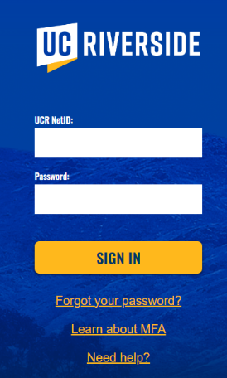

1. Click on PeopleSoft Homepage (right top of the screen)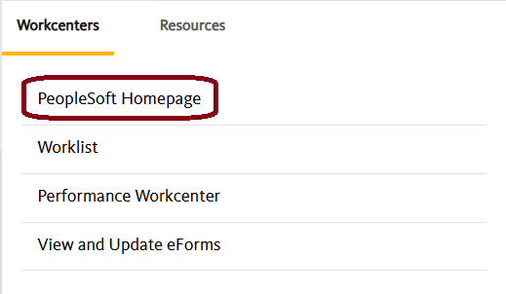
2. Use the drop-down menu and change Workforce Administration to General Ledger Administration 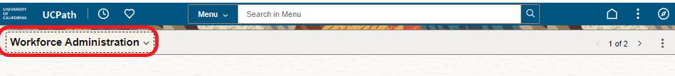
3. Click on General Ledger Tasks  
    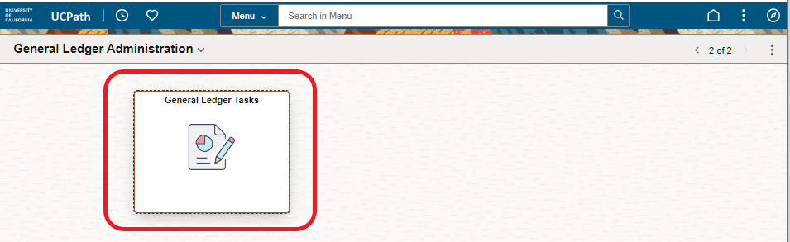
4. Main Screen

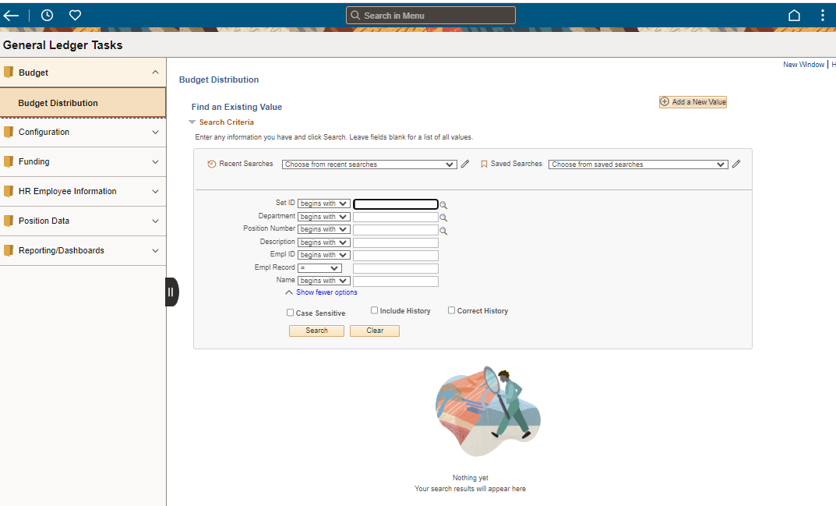

1. Processing/loading icon located in the top right corner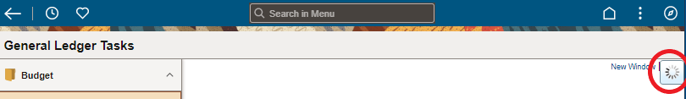

**Budget Distribution Navigation**

This is the main section where most transactions will take place. (i.e., adding a position into BDP, changing the rate from a salary action, indicating the position needs to be on/off the staffing report, updating a group provision).

1. Open Budget Folder
2. Click on Budget Distribution
3. Select a Criteria then click on Search
   1. *Add the Set ID as RVCMP*
   2. *e.g. you can search for specific positions with a position number or by an entire department.* 
      1. *Best practice is to search by position number or employee ID.*

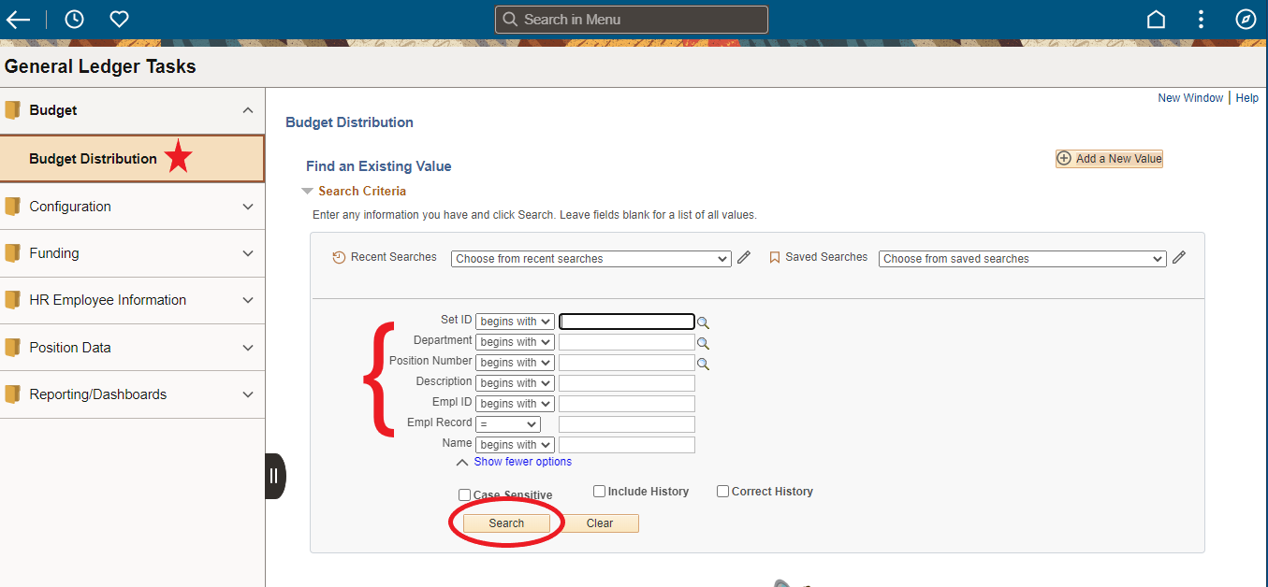

1. The results will populate below and click on the arrow (>) located to the right (next to the name), to view the record. 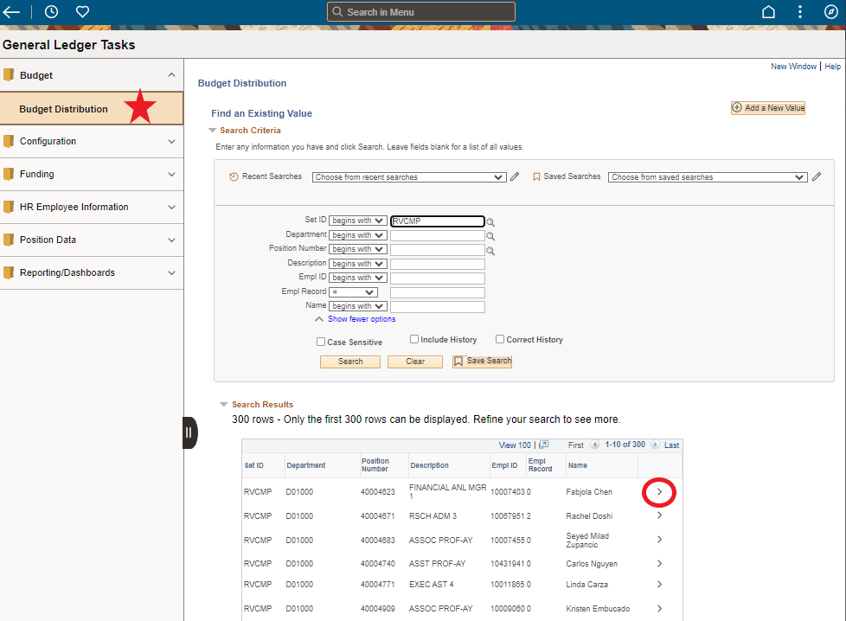
2. The record will look like this: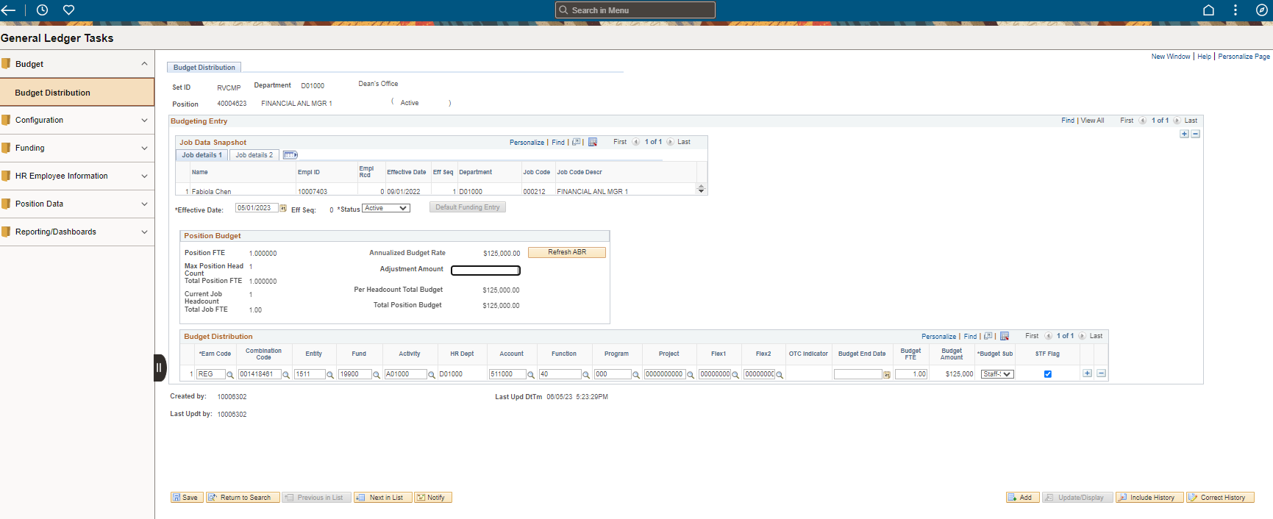
3. This section shows the details of the position
   1. Budget Distributions shows
      1. Department code and Name
      2. Position Number and Title
      3. Status Active 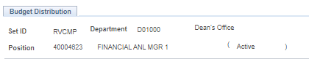
   2. Budgeting Entry
      1. Job Data Snapshot – shows the details of the position (Name, Employee ID, Effective Date, Department, Job Code & Job Code Description).

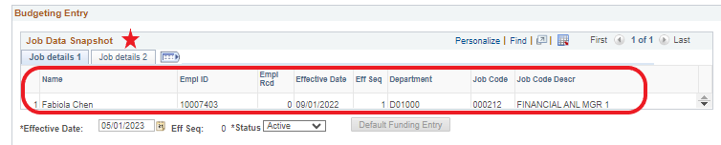

* + 1. Effective Date
    2. Status of the position

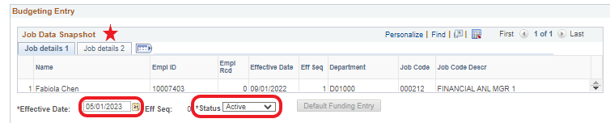

* 1. Position Budget
     1. FTE
     2. Annualized Rate – current salary in the system
     3. Adjustment amount – is where you add the additional amount to the salary
     4. Refresh ABR used when you add a value to the Adjustment Amount.

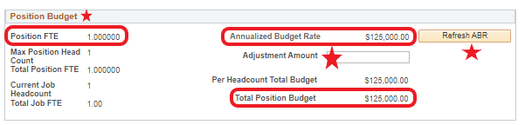

* 1. Budget Distribution
     1. COA that is being charged for the salary
     2. Budget FTE
     3. Budget Sub – drop down box to select the appropriate classification for the position
     4. STF Flag – this a budgeted position and is a part of staffing if the STF Flag is checked.

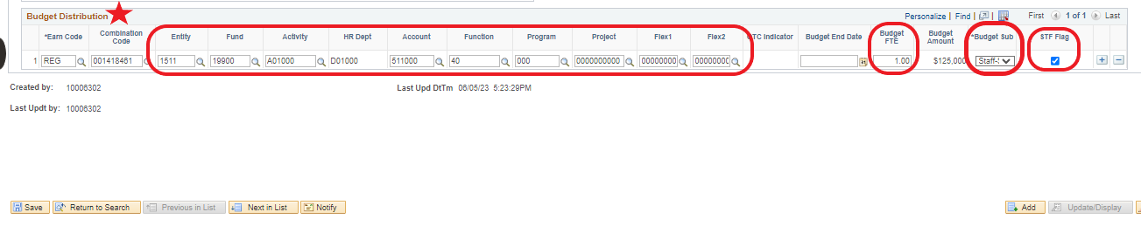

* 1. Add is used if additional COA are needed (split positions).

* 1. To make changes to the position record, click the + in the top right corner
  2. Update the effective date (shown in step B above)
  3. Adjust the areas needed
  4. Save
  5. Return to search



# **Searching for Position Details**

This is good for seeing the compensation history, Job History of an employee, and many other details.

1. Go to ‘HR Employee Information’ > ‘Workforce Job Summary’
   1. Enter either the position number, Employee ID, employee name, Department code and/or Job code (for a broader result less information entered the better when searching with department or job code)
   2. Click on search

* 1. The search results will populate below.
  2. Click on the > to view the details of that line.

# **Searching for Position Numbers**

*To search for a position, you will need to have a Department Code, Job Code or the Position Number.

1. Click on Position Data.
2. Add/Update Position Info.
3. Add the Department Code and/or Job Code or the position number if know.
   1. Department code or Job Code individual can be used for a broader searcher result.
4. Click on Search.
5. The position will populate in the Search Results below

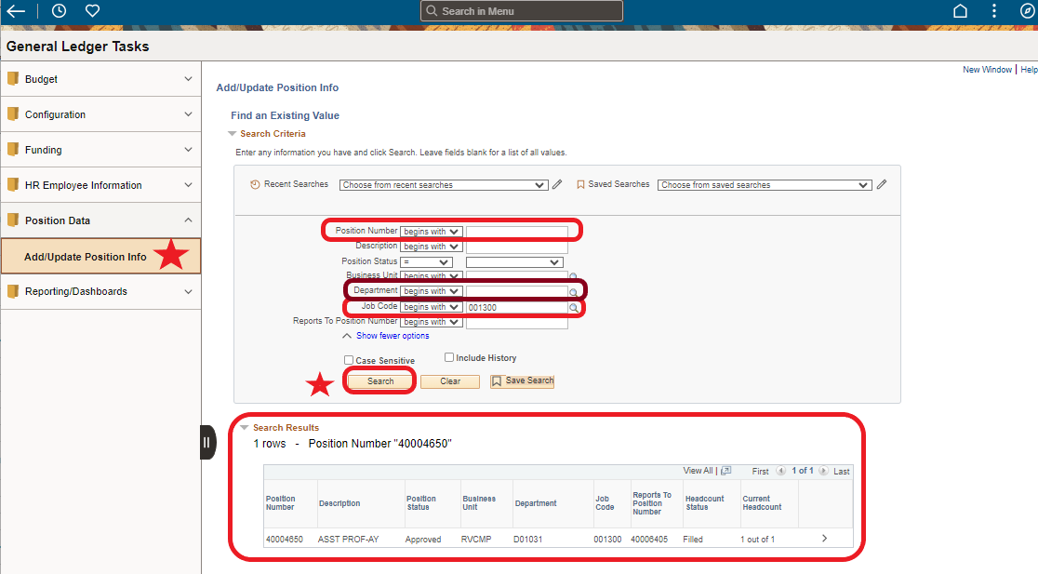

1. Click on the > to view the details of the position

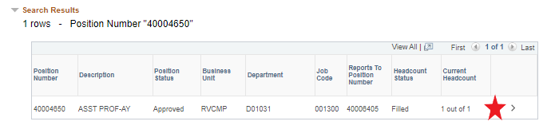

1. Description  
    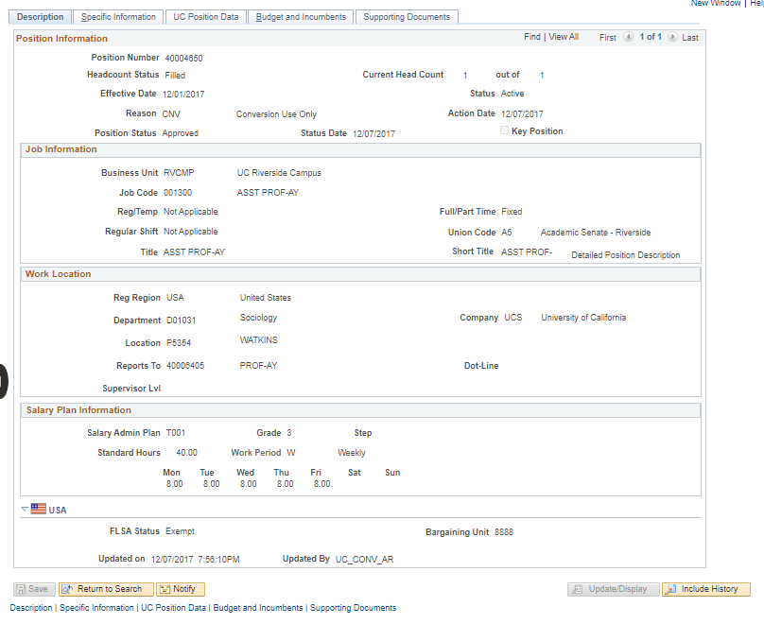

**If the position you are looking for is not in BDP, then you will have to add it. Please follow the steps in Adding Position Numbers to BDP.

# **Adding Position Numbers in BDP**

*Now that you’ve searched for a position number, you can go back into BDP to add that position as a value.*

1. To add a position into BDP, click on Add a New Value

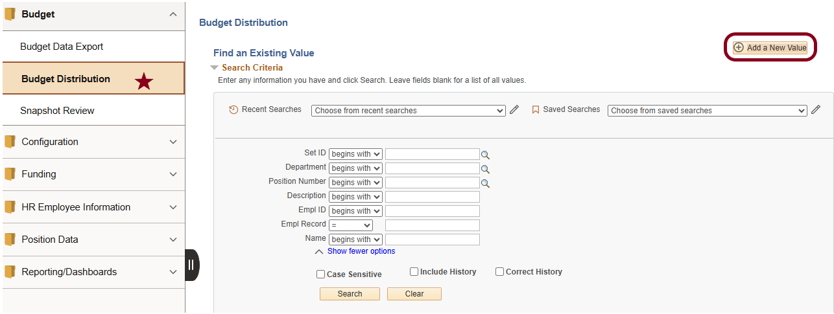

1. Enter the department code and position number.
2. Click add

1. Click on the + (top right side of the screen) to start updating the position

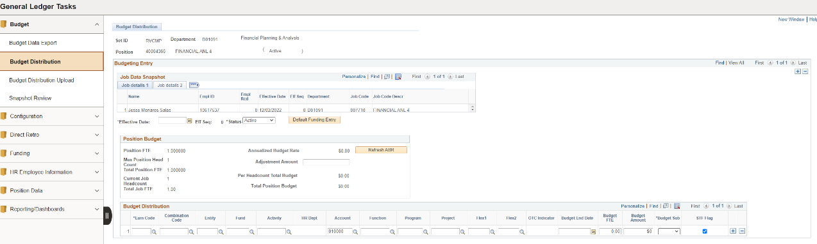

1. Add an effective date, (ideally todays date, but it can be backdated)
   1. Confirm that the Job Data Snapshot information is correct.

1. Adjust the Position Budgets as needed (this is mostly updated for vacant positions or open provision).
   1. The below ABR message may populate if the salary amount has changed since the last time the position was adjusted.
      1. Okay to accept the change
      2. Cancel to keep the data as is

* 1. Click on the Refresh ABR if you are making adjustments to the “Adjustment Amount” section

* 1. Budget Distribution –
     1. Enter/Adjust the COA
     2. Enter the Budgeted FTE
        1. The position Budgeted amount will adjust per the FTE in the Budget amount section
     3. Use the drop down box for the correct Budget Sub.
     4. Click on the STF Flag if you want the COA details on the staffing report.
        1. Note if the Position Department code is different from the HR Department code, the position may not populate correctly in Oracle budget. A new position number will need to be created by the shared service center to reflect this correctly.
     5. Click the + if you need to split fund the position. (no limit on how many COAs can be added here) and not all COAs need to have the STF Flag selected.
        1. Use the – to remove the COA line
     6. Click on Save

# **Split Funding Someone Currently in BDP (not in Funding Entry)**

How to split fund an existing position for staffing purposes only. This does not affect the actual pay as a separate transaction needs to take place in UCPath.

1. Go into Budget Distribution
2. Set ID needs to be RVCMP
3. Enter the position number
4. Click search
5. Click on the > next to the correct details for more information

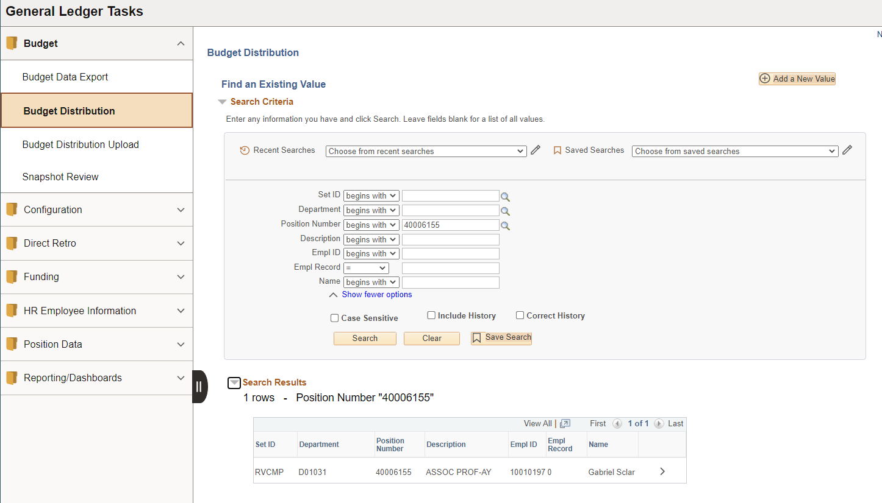

1. Click the + if you need to split fund the position. (no limit on how many COAs can be added here) and not all COAs need to have the STF Flag selected.
   1. Use the – to remove the COA line
2. Click on Save

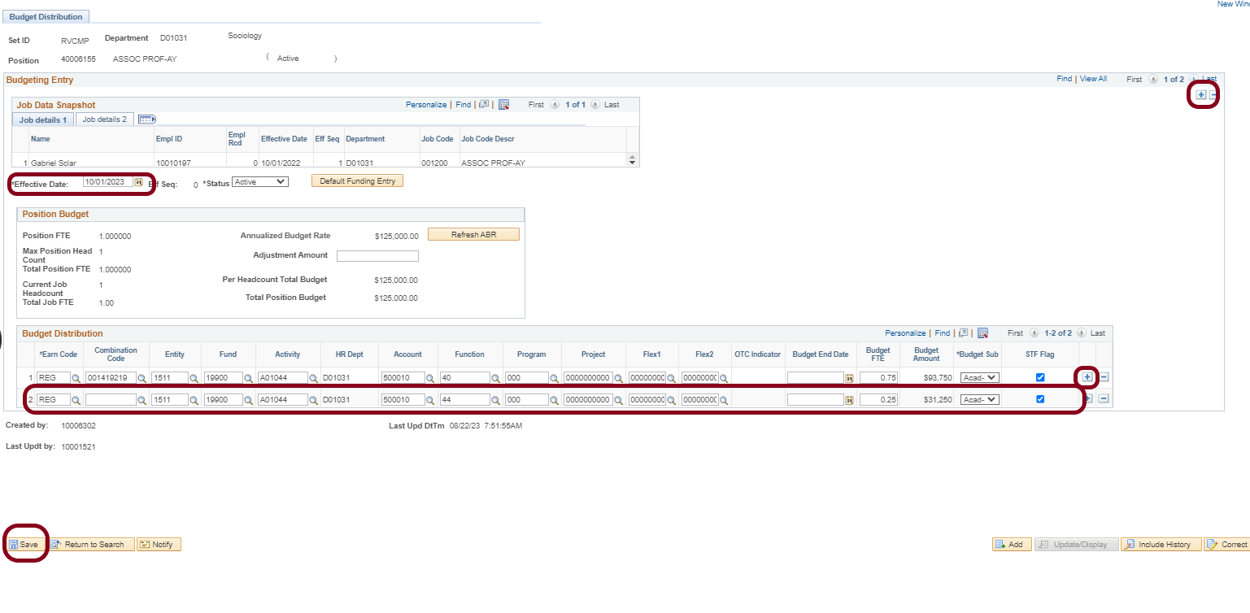

**Updating a Position/employee with a new salary action**

This will be used for actions such as Merits & Promotion, Range Adjustment, Retentions, Across the Boards, Reclassification, Union Contract Increases, etc. The staffing reports will show the correct salary, only the BDP page will show the last salary action until the position/employee is refreshed in BDP.

1. Budget Distribution
2. Enter search criteria and click search
3. Click the >

1. Click on the + in the Budget Entry section to add a new row
2. Add an effective date
3. Enter the “Adjusted Amount” (positive or negative) and then click “refresh ABR”.
4. Verify the amounts are correct in the “Position Budget” and the “Budget Distribution” Sections
5. Click save.

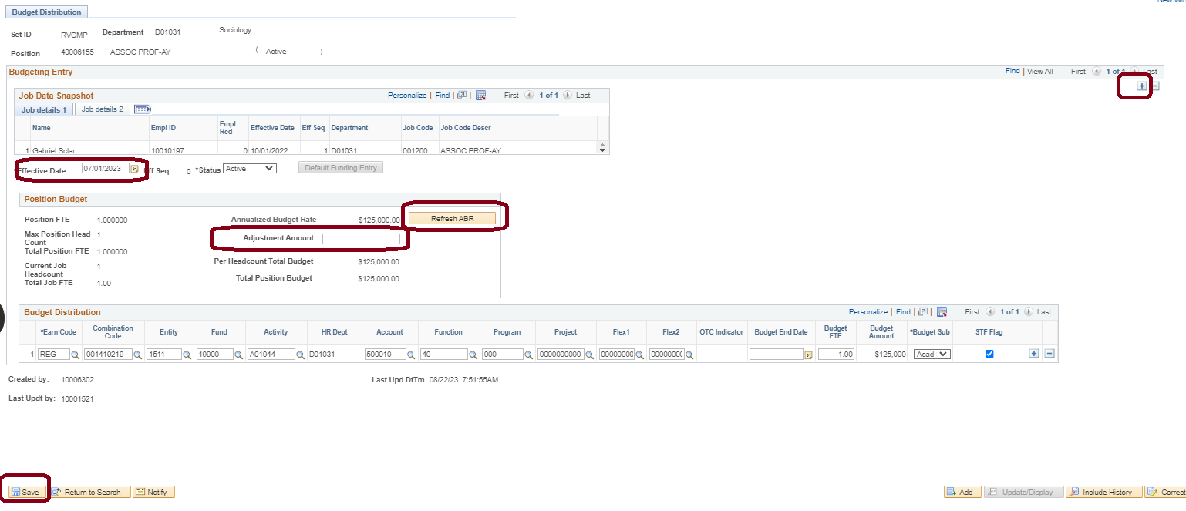

# **Termination or Vacant Position**

When an employee leaves a position it goes to the lowest salary range and the position needs to be adjusted to the budgeted amount.

*Note: a pop-up box will ask to keep the ABR or Update to the new rate. Click cancel to keep the last updated rate as the system will default to the bottom of the range.

1. Budget Distribution
2. Position Number and click search
3. Click on the >

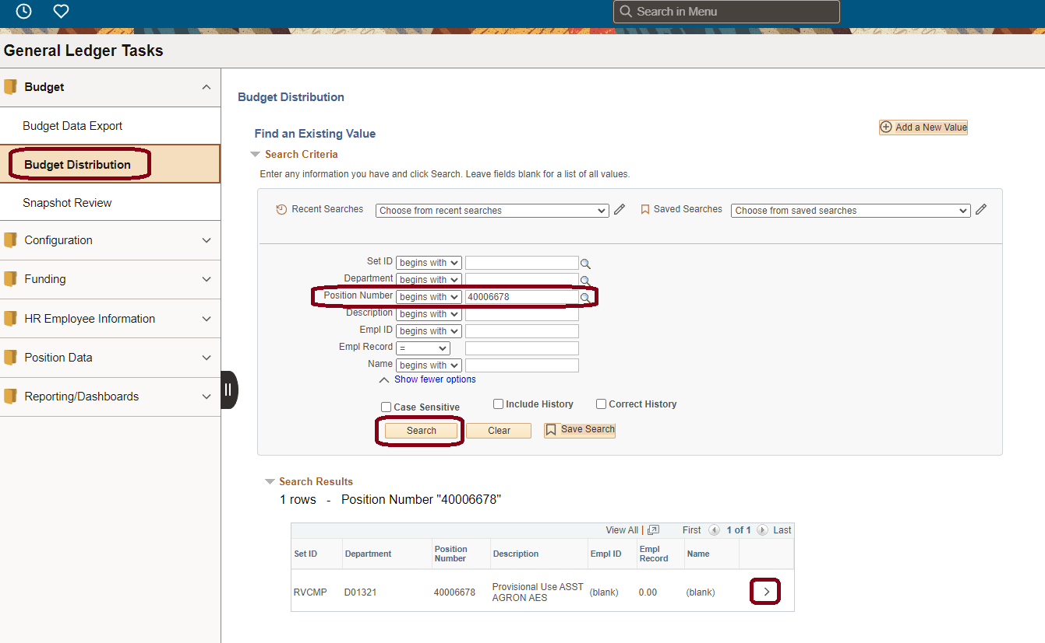

1. You will get this message, click cancel

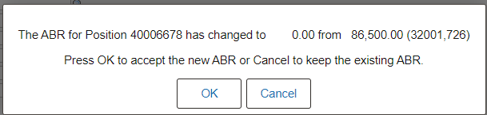

1. Click on the right + to add a new effective date
   1. The effect date can be as of today's date or any previous date during the fiscal year.
2. Make the adjustments needed and save.

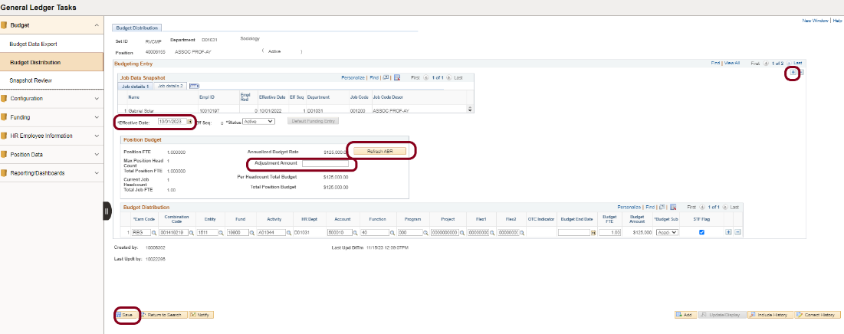

# **How to change an existing Group Provision?**

A group provision is needed to hold unused funding and FTE for vacant positions.

1. Budget Distribution
2. Position Number and click search
3. Click on the >



1. If you get this message, click cancel



1. Click on the right + to add a new effective date
   1. The effect date can be as of today's date or any previous date during the fiscal year.
2. Make the adjustments needed and save.

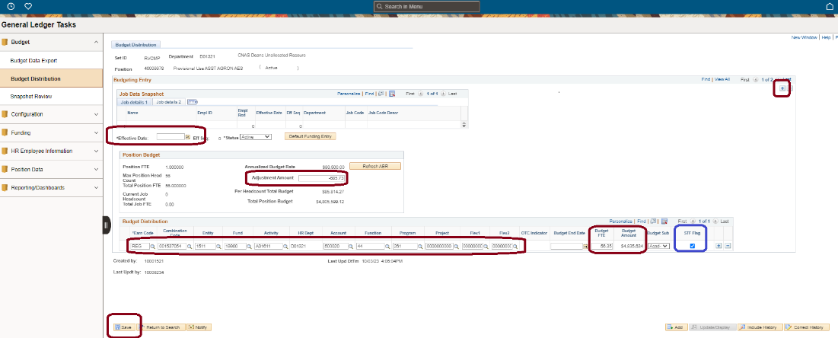

**Modifying Preexisting Group Provision**

1. Group Provisions should be in the position name
2. [Calculator](https://docs.google.com/spreadsheets/d/1wquOhVKX7i9HIwRHsIckVSMV3G3pj6jK/edit?gid=2097448677#gid=2097448677) to help with this. Note that for the calculator to work appropriately, the dollar values you enter must be whole numbers and the FTE must not have more than 2 values after the decimal.
3. If the position FTE is 0.00 the system will not allow you to make adjustments to the Budgeted Amount in the distribution line.

**How to add/remove a position into staffing**

To add/remove a position in staffing that does/does not belong for staffing proposes only. This does not affect the actual pay as a separate transaction needs to take place in UCPath.

1. Budget Distribution
2. Position Number and click search
3. Click on the >



1. If you get this message, click cancel



1. Click on the right + to add a new effective date
   1. The effect date can be as of today's date or any previous date during the fiscal year.
2. Click on the “STF Flag” box. (normally you must click twice for it to fully uncheck)
3. Click Save

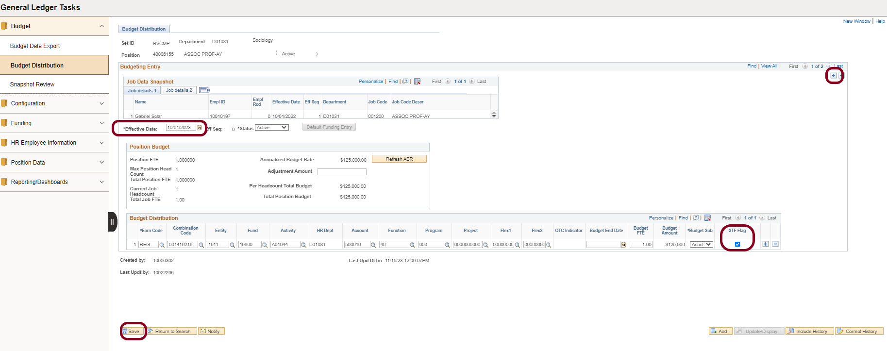

**Known Errors Messages**

This message is when your FTE do not balance to the UCPath FTE amount.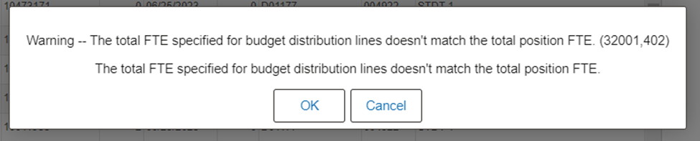

This message is received when the amount in BDP is different than what's in UCPath

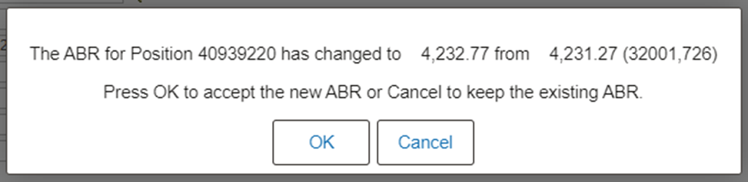

Create a new effective date and then STF flag needs to be unchecked twice

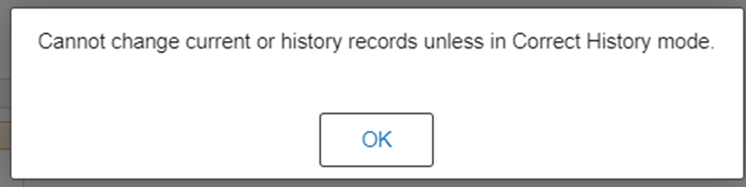

If you uncheck STF flag but did not add a new eff date row.



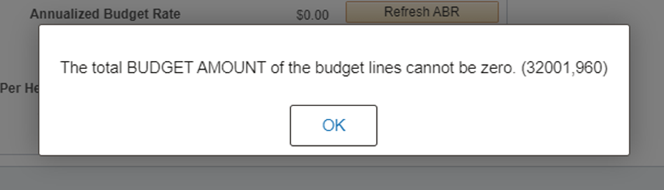

This happened when there was FTE without a budget. Need to add $1.00.